Climate Change Has Intensified Drought in The Middle East Over the Last Century
Ali Darvishi Boloorani ^{a, b, c*}, Nastaran Nasiri ^{b, d}, Ramin Papi ^{e}, Masoud Soleimani ^{a, b}, Najmeh Neysani Samany ^{a, b}, Ali Al-Hemoud ^{f, g}, Kan Huang ^{h*}, Ali Al-Dousari ^{f}
ª Department of Remote Sensing and GIS, Faculty of Geography, University of Tehran, Tehran, Iran
^{b} Research Institute for Development of Space Science, Technology, and Applications, University of Tehran, Tehran, Iran
^{c} GeoAI Environmental Engineering Consultancy L.L.C, Abu Dhabi, UAE
^{d} Department of Water Resources Engineering, Faculty of Civil, Water and Environmental Engineering, Shahid Beheshti University, Tehran, Iran
^{e} National Cartographic Center (NCC), Tehran, Iran
^{f} Environment and Life Sciences Research Center, Kuwait Institute for Scientific Research, Kuwait
^{g} Department of Environmental Health, Harvard T. H. Chan School of Public Health, Harvard University, Boston, MA, USA
^{h} Center for Atmospheric Chemistry, Department of Environmental Science and Technology, Fudan University, China
*Corresponding authors: ali.darvishi@ut.ac.ir & huangkan@fudan.edu.cn
Abstract
Study Region: The Middle East, one of the most drought-affected regions globally, faces increasing pressure on the water resources, food security, ecosystems, and socio-economic systems. Despite its high vulnerability, comprehensive long-term assessments of drought dynamics over a century scale remain limited.
Study Focus: This study investigates meteorological drought variability and trends over more than a century (1901–2022) using the Standardized Precipitation-Evapotranspiration Index (SPEI) combined with statistical analyses. A climate change breakpoint around 1976 was identified, indicating a regime shift toward more frequent and intense drought conditions. The timing of this transition varied spatially, occurring as early as 1965 in Türkiye and as late as 1993 in Egypt and the Levant. Post-breakpoint changes in drought frequency, duration, and intensity were quantified across subregions.
New Hydrological Insights for the Region: Results demonstrate a substantial intensification and spatial expansion of drought conditions after the breakpoint. Drought intensity increased markedly in southern Egypt and southeastern and southwestern Saudi Arabia, while parts of Yemen experienced reduced severity. In the 21st century, drought-affected areas expanded significantly, with summer drought frequency increasing by up to 60 % in Saudi Arabia, Iran, Iraq, United Arab Emirates, and Oman. Maximum drought duration increased by 87.5 % in southern Egypt, 46.7 % in southwestern Iran, 78.6 % in the Levant, and 56.3 % in the southeastern and southwestern Arabian Peninsula. Maximum drought intensity rose by 209 % in the Arabian Peninsula, 155.6 % in Iran, and 35.8 % in the Levant. In contrast, Türkiye remained relatively stable, likely due to its distinct topographic and climatic characteristics. Since 2000, drought frequency has increased notably during warmer seasons, with summer being the most affected, whereas winter conditions have remained comparatively stable, particularly in Türkiye, Syria, and northern Iraq. These findings highlight an accelerating drought pattern shift across the Middle East and emphasize the urgent need for enhanced climate adaptation strategies, including improved water resource management, strengthened agricultural resilience, and proactive urban planning to mitigate the impacts of prolonged and intensifying drought events.
Keywords: Climate change, Drought, Spatiotemporal analysis, Breakpoint analysis, Middle East.
1. Introduction
Drought is a natural, gradual, and recurring hydroclimatic hazard characterized by an abnormal and persistent decrease in precipitation compared to the normal climatic conditions of a region (Mishra & Singh, 2010; Van Loon et al., 2016; Schwalm et al., 2017). This phenomenon is typically categorized into four main types: meteorological, agricultural, hydrological, and socio-economic drought (Hagenlocher et al., 2019). Meteorological drought, which is usually considered the initiator of a drought chain, occurs when precipitation during a given period is significantly below the region's long-term average (Van Loon, 2015). Other types of droughts can occur after precipitation deficits, with specific time lags influenced by geographic conditions (Darvishi Boloorani et al., 2024a). Drought has widespread direct and indirect consequences, including water scarcity, reduced crop yield, food insecurity, desertification, ecosystem disruption, and social challenges such as economic losses and forced migration (Linke et al., 2018; Kuwayama et al., 2019; Vicente-Serrano et al., 2020; Müller & Bahn, 2022; Darvishi Boloorani et al., 2024b).
In recent decades, the pattern of drought has changed as a result of greenhouse gas emissions and the subsequent impacts of climate change. Climate change increases the frequency, intensity, and duration of droughts in many regions worldwide (Haile et al., 2020; Zhao et al., 2023; Gond et al., 2023a), as well as the spread of drought across different areas (Apurv et al., 2017). Rising temperatures and changing precipitation patterns are disrupting the water cycle and exacerbating water scarcity in many areas (Al-Dousari et al., 2020). The changes are particularly noticeable in the Middle East, where already arid conditions are being exacerbated by more frequent and severe meteorological droughts (Darvishi Boloorani et al., 2024a). The effects of climate change on drought are not uniform and symmetrical across all regions of the world. Some areas in the Middle East are experiencing droughts that are twice as severe as global droughts and occurring more rapidly (Zittis et al., 2022). The interaction of drought and human activities in the Middle East, such as unsustainable management of water, soil, and plant resources (Darvishi Boloorani et al., 2021; Al-Dousari et al., 2022; Akbari et al., 2022), has led to a variety of environmental challenges, including land degradation, soil erosion, abandonment of agricultural lands, destruction of rangelands, and the occurrence of dust storms (Darvishi Boloorani et al., 2024c). The interplay of these factors has exacerbated the dire circumstances in drought-stricken regions of the Middle East (AghaKouchak et al., 2021). Hence, understanding and monitoring drought is crucial to developing effective strategies to mitigate and adapt to its impacts, given its varied and widespread consequences globally (Van Loon, 2015).
Conducting quantitative spatiotemporal assessments necessitates access to reliable data sources, which is imperative for a comprehensive understanding of drought characteristics and the adoption of effective management measures. This challenge is considered a primary focus in the field of drought monitoring (Alahacoon & Edirisinghe, 2022; Han & Singh, 2023; Zhang et al., 2025). Numerous indices have been developed to assess droughts, each with its own set of strengths and limitations. These indices can be calculated with data from meteorological stations and satellite remote sensing, the latter of which is preferred due to its wide and continuous spatiotemporal coverage and ease of access (Kushwaha et al., 2022). Widely utilized indices in this context consist of the Standardized Precipitation Index (SPI), the Palmer Drought Severity Index (PDSI), and the Standardized Precipitation Evapotranspiration Index (SPEI) (Salimi et al., 2021). SPEI is particularly beneficial among drought indices because it considers both precipitation and potential evapotranspiration, leading to a more thorough evaluation of drought conditions. Besides, unlike the SPI, which solely considers precipitation, the SPEI incorporates the influence of temperature variations, making it more responsive to the consequences of climate change (Nwayor & Robeson, 2024; Gond et al., 2023b). Therefore, applying SPEI in regions such as the Middle East, which are heavily affected by climate change, can offer a more accurate understanding of hydroclimatic impacts. The drought situation and its consequences are worsening in the Middle East, as noted in the literature. To the best of our knowledge, understanding drought dynamics is essential for effective management. This underscores the necessity for a thorough investigation of this phenomenon. Given this context, several studies, mainly at the local scale, have attempted to monitor and assess drought hazard in the Middle East (Fadhil, 2011; Sharifikia, 2013; Tabari et al., 2013; Mathbout et al., 2018; Ejaz & Bahrawi, 2022; Sharafi & Ghaleni, 2022; Al-Hemoud et al., 2023; Soylu Pekpostalci et al., 2023). Previous studies have utilized various data and methods across different regions in the Middle East, making it challenging to reach a comprehensive conclusion and understanding of the phenomenon. There remains a significant need for a more comprehensive and large-scale exploration to fully understand drought and the interrelated impacts of climate change in the region. This study aims to bridge the knowledge gap by utilizing the SPEI to analyze meteorological drought patterns in the Middle East. Moreover, we endeavor to furnish a spatiotemporal comprehension of the drought situation in the Middle East, whereas prior studies have predominantly undertaken temporal analyses at a local country level. In this regard, analyses are conducted on the intensity, return periods, and breakpoints in the time series of SPEI-based meteorological drought patterns in relation to climate change.

2. Materials and methods
2.1. Research design
The primary goal of this research is to characterize drought dynamics in the Middle East, a hotspot for regions affected by climate change worldwide. To achieve this goal, based on the assumption that climate change has altered the dynamics of drought in the Middle East, six main questions are raised:
- What is the turning/break points of long-term drought change trends?
- What is the pattern of spatiotemporal changes in drought intensity?
- Have the return periods of drought events shifted over time? What is the spatial distribution of these changes?
- What is the spatiotemporal drought duration pattern in the region?
- What are the temporal and spatial patterns of drought area across varying intensity levels?
- How has drought frequency varied across different seasons?
The proposed methodology uses a global 0.5° gridded dataset in combination with spatiotemporal and statistical analyses to address the research questions. Meteorological drought dynamics, including spatial–temporal variation, frequency, intensity, duration, and return periods, based on the SPEI-1 time series were investigated. A drought event is defined as a continuous period during which SPEI-1 falls below 0; duration refers to its length (in months), intensity to the magnitude of the SPEI deficit, frequency to the number of such events, and return period to the estimated recurrence interval derived from probability distribution fitting. For a more detailed regional assessment, the Middle East was divided into five subregions according to the Köppen climate classification (Table 1). The overall research workflow consisted of six stages, as illustrated in Fig. 1.

Table 1. Dividing the Middle East into climatically homogeneous subregions based on the Köppen classification.
Subregion No. | Subregion name | Description
1 | Iran | A combination of mountain and desert climates, characterized by significant variations in temperature and precipitation.
2 | Egypt | Predominantly arid climate, with the Nile River as the main water resource.
3 | Türkiye | Includes mountain areas with a relatively colder climate and more precipitation than the rest of the region.
4 | Levant (Shamat) | It encompasses countries with climates ranging from semi-arid to Mediterranean, including Iraq, Syria, Lebanon, and Jordan.
5 | Arabian Peninsula | It includes Saudi Arabia, Kuwait, Qatar, Bahrain, Emirates, Oman, and Yemen, which have mostly desert and very dry climates.
6 | The whole region (Middle East) | Which includes all above subregions.

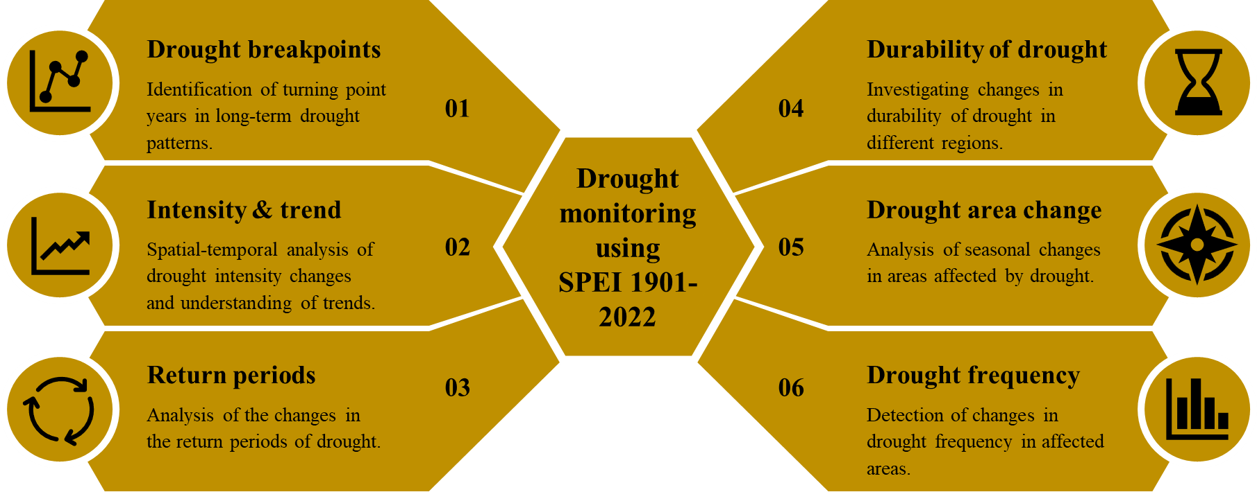
Fig. 1. Schematic representation of the research flow: main steps of spatiotemporal analyses based on the standardized precipitation evapotranspiration index (SPEI) to characterize meteorological drought dynamics in the Middle East.

2.2. Quantification of meteorological drought
The selection of an appropriate drought index is essential for the investigation of meteorological drought in the study area. The Middle East has a predominantly arid climate with an average annual rainfall of less than 350 mm. In addition, the region lies between 12°– 45° N latitude, resulting in significant temperature and evapotranspiration variability. As Vicente-Serrano et al. (2010) pointed out, the SPEI is an enhanced drought index that is particularly useful for studying the effects of global warming on drought intensity. Accordingly, given the Middle East's prominence in terms of the effects of climate change caused by global warming (Zittis et al., 2022), it emphasizes the appropriateness of SPEI. In addition to precipitation (P), potential evapotranspiration (PET) is also used in the calculation of SPEI, which allows us to indirectly quantify the effect of temperature on the intensity and duration of drought (Vicente-Serrano et al., 2010; Beguería et al., 2014). This feature makes SPEI suitable for investigating short-term droughts over large areas, such as the Middle East, with high climatic variability. Considering the dynamic nature of drought and its diverse effects on different environmental components, the ability to calculate SPEI in a multiscalar manner allows for the discrimination of various types of droughts (Vicente-Serrano et al., 2010).
Here, the one-month SPEI (SPEI-1) was selected, considering its characteristics and application, as well as the hydroclimatic conditions of the study area, to quantify and monitor spatiotemporal patterns of meteorological drought. The calculation of the SPEI-1 consists of two main steps: (i) the monthly water balance is calculated as the difference between P and PET; (ii) the water balance values are transformed into a normal distribution and standardized using the mean (μ) and standard deviation (σ), allowing SPEI values to be comparable. SPEI values range from -4 to 4, with negative values indicating drought and positive values indicating wet condition. Although the calculation of SPEI based on station observations is generally more accurate, and some studies compute SPEI from station datasets to analyze local drought conditions (Gond et al., 2025), this approach is not feasible for an extensive study area such as the Middle East. Meteorological stations in this region are sparse and unevenly distributed, and they often do not provide sufficiently long-term records. Therefore, the global SPEI database (SPEIbase v2.9) was obtained from Google Earth Engine (GEE). This dataset has a spatial resolution of 0.5° (~55 km) and a monthly temporal resolution, covering the period from 1901 to 2022 (Beguería et al., 2023), and was used for the SPEI analysis.

2.3. Identification of the region-specific breakpoints in the SPEI time series
Identifying breakpoints in the SPEI time series is essential, as it signifies sudden or gradual changes in the intensity, duration, and sequence of droughts (He et al., 2021). The study period (1901-2022) was divided into two periods, before and after the breakpoint, to analyze how meteorological drought characteristics are changed over time. Here, the breakpoint is regarded as a change in the temporal patterns of drought in the region due to the influence of climate change components (e.g., changes in precipitation, evapotranspiration, land use/cover, human intervention, etc.). Separating the time series at key breakpoints allows for better analysis of drought patterns before and after climate change (He et al., 2021). To avoid the effect of seasonality in the monthly SPEI-1 series, we first converted the data into annual values. The yearly mean of SPEI-1 was calculated and used for breakpoint detection. This approach removes seasonal variation and allows the detected breakpoints to represent long-term changes rather than monthly fluctuations. Breakpoints in the SPEI time series for different subregions (Table 1) were identified using several statistical methods, including Pettitt's test (Pettitt, 1979), Bayesian change point detection (Adams & MacKay, 2007), Standard Normal Homogeneity Test (SNHT) (Alexandersson, 1986), and Von Neumann's ratio test (Von Neumann, 1941).These methods are common tools for detecting structural changes in hydroclimatic time series data, enabling the identification of significant discontinuities (Xie et al., 2019; Wang et al., 2021). In this study, the XLSTAT (https://www.xlstat.com) add-in for Excel was utilized for breakpoint analysis. Due to the varying results from different methods, the final breakpoint for each subregion was selected based on the point identified by at least two independent methods with accepted confidence levels (p-value < 0.05).

2.4. Statistical analysis of the trend in the SPEI time series
To analyze drought trends in different parts of the study area, the nonparametric Mann-Kendall test was used at three-time scales: before and after the SPEI breakpoint and for the entire study period. This analysis aimed to identify the spatiotemporal changes in drought intensity and duration as a result of climate change and hydrological fluctuations.
The Mann-Kendall test is a widely used nonparametric statistical method for detecting trends in time series data (Mann, 1945). It is particularly popular in environmental, climate, and hydrological studies because it does not require that the data follow a normal distribution (Mann, 1945). The test works by making pairwise comparisons of data values over time to determine whether there is a significant upward, downward, or no trend.
In this study, the Mann-Kendall tau (τ) statistic was calculated for each pixel in the area to explore the spatial changes in drought trends. The value of τ varies from -1 to 1, with positive values for SPEI indicating an increasing trend (i.e., decreasing drought) and negative values indicating a decreasing trend (i.e., increasing drought) (Hamed & Ramachandra Rao, 1998). The significance level of the trend was determined using the p-value analysis. A p-value of less than 0.05 indicates a significant trend at the 95% confidence level, and a p-value of less than 0.01 indicates a significant trend at the 99% confidence level.

2.5. Spatiotemporal analysis of variability in SPEI intensities
Study area experiences varying spatiotemporal SPEI intensities due to different hydroclimatic conditions. To illustrate this variability, we calculated the frequency of SPEI, expressed as the number of months that each pixel experienced different levels of SPEI intensity. Specifically, we categorized the SPEI into six intensity levels, including: “SPEI < -2”, “-2 < SPEI < -1”, “-1 < SPEI < 0”, “0 < SPEI < 1”, “1 < SPEI < 2”, and “SPEI > 2”. This analysis reveals which SPEI levels are more prevalent in the study area over the period 1901-2022.
In addition, to determine the extent of areas affected by different SPEI intensities, the annual sum of pixel areas associated with these monthly SPEI levels was calculated over the years 1901-2022. This analysis was conducted for all subregions (Table 1) to illustrate how the spatial extent of pixels experiencing varying intensities of meteorological drought has changed over time.

2.6. Analysis of SPEI seasonal patterns
To investigate how climate change affects the seasonality of meteorological drought, the monthly SPEI values during 1901-2022 were compared for two periods: before and after the breakpoints of SPEI in each subregion. The Friedman test (Friedman, 1937) was used to evaluate significant differences in the range of SPEI values across different months of the year. This non-parametric test was chosen because the datasets did not follow a normal distribution, allowing for a more accurate analysis of the entire range of SPEI values. The SPEI values for each month were considered as distinct groups, allowing for easy comparison and analysis. A p-value less than 0.05 indicates statistically significant differences in monthly SPEI values, indicating variable drought intensity throughout the year.

2.7. Evaluation of changes in SPEI return periods
Here, the return periods for SPEI were calculated before and after the breakpoints to facilitate comparison for each subregion. As the mean of image collection in each subregion can smooth the results and obscure extreme values, the return periods were calculated not only for the mean time series of SPEI but also for the 5th percentile interval.
Finding the best probability distribution for SPEI was challenging. To address this, we randomly selected approximately 10 points from various locations across the Middle East and tested the SPEI time series at each point using the Chi-square test and the Kolmogorov-Smirnov (K–S) test to identify the best-fitting distribution among Generalized Extreme Value (GEV), Gamma, and Gumbel. Based on a 5% significance level (p-value < 0.05) and the results from both tests, we selected the distribution identified as the best fit for the majority of points for the analysis.
The GEV distribution was employed to model the return periods of SPEI values, which is effective for characterizing both moderate and extreme hydroclimatic conditions (Ouarda & Charron, 2019). It is important to note that the GEV distribution (Eq. 1) was fitted to the complete monthly SPEI-1 time series from 1901 to 2022 for each subregion, rather than solely to absolute extremes. This approach allows for the estimation of recurrence intervals for varying drought intensities, ensuring statistical robustness. To calculate the return period using the GEV distribution, we first estimated the GEV parameters—location, scale, and shape—based on the full SPEI dataset (Reiss et al., 1997). After estimating these parameters, we utilized the inverse of the cumulative distribution function (CDF) (Eq. 2) to determine the SPEI intensity corresponding to specific return periods. The return period itself is the reciprocal of the exceedance probability, calculated using Eq. 3 (Volpi et al., 2015). Consequently, the SPEI intensity values associated with different return periods derived, reflecting the probability of exceeding those intensities in any given month, which is particularly relevant given the long duration of the dataset and the generally arid climate of the Middle East.
$$f(x∣μ,σ,ξ)=\frac{1}{σ}exp⁡[-{(1+ξ\frac{(x-μ)}{σ})}^{-1/ξ}]{(1+ξ\frac{(x-μ)}{σ})}^{-1-1/ξ}$$ | Eq. (1)
$$F(x∣μ,σ,ξ)=exp⁡[-{(1+ξ\frac{(x-μ)}{σ})}^{-1/ξ}]$$ | Eq. (2)
$$T=\frac{1}{P}$$ | Eq. (3)
Where, μ represents the location, σ is the scale (which must be greater than zero), and ξ is the shape parameter of the GEV distribution, T is return period, and P is the probability corresponding to the specific SPEI intensity extracted by CDF function.
To account for uncertainty, the bootstrapping method was used with 1000 samples. Bootstrapping involves repeatedly resampling the data with replacement to create numerous simulated samples that help estimate the variability and confidence intervals (Efron, 1992). The 5th and 95th percentiles of these samples were used to create a confidence interval for the calculated return periods.

2.8. Evaluation of changes in SPEI duration
Since the frequency of SPEI was evaluated indirectly through the return period, it is also necessary to investigate the duration patterns of SPEI in different subregions of the study area and to interpret the possible changes before and after the identified breakpoints. For this purpose, the monthly time series of mean SPEI were analyzed. SPEI values lower than -0.5 were considered as meteorological drought. This threshold was determined by trial and error based on the longest known droughts in the Middle East. We calculated the mean and maximum of the drought duration before and after the region-specific breakpoints to investigate whether the duration of droughts has increased or decreased in recent decades compared to the past.

2.9. Analysis of drought spread
The extent of drought-affected areas could vary significantly in different seasons, primarily because meteorological drought is strongly influenced by seasonal variations in precipitation and temperature. These climatic factors can reach extreme levels during specific months and seasons, which in turn affect the intensity and spread of drought conditions (Darvishi Boloorani et al., 2024a). Here, to quantify the areas affected by meteorological drought across different seasons in the subregions, we analyzed the time series of the mean areas exhibiting an SPEI of less than -1 for each season.

2.10. Change detection of drought frequency
Here, the number of months in different seasons during the period 1901-2022 with an SPEI of less than -1 was calculated on a pixel-by-pixel basis, both before and after a defined breakpoint for the entire study area. This provides a clear understanding of how drought conditions have evolved over time. To ensure comparability, the number of months with an SPEI below -1 was normalized by the total number of months in each season within the respective periods (before and after the breakpoint). Specifically, for each season (e.g., summer: June, July, and August), we first determined the total number of months with an SPEI less than -1 during the period before the breakpoint and divided this by the total number of months in that period. The same calculation was performed for the period after the breakpoint. To evaluate the change in drought frequency, the normalized values for the periods before and after the breakpoint were subtracted, as shown in Eq. 4:
$$∆N= \left(\frac{D_{AB}}{T_{AB}}\right)-\left(\frac{D_{BB}}{T_{BB}}\right)$$ | Eq. (4)
Where, $D_{AB}$ and $D_{BB}$ represents the number of months with an SPEI less than -1 after the breakpoint and before the breakpoint, respectively. $T_{AB}$ and $T_{BB}$ are the total number of months after and before the breakpoint.
2.11. Assessment of change in the main component of SPEI
The main components of SPEI calculation are precipitation and potential evapotranspiration (PET). PET is primarily calculated using the Penman–Monteith method, which is a physically based approach that incorporates temperature, wind speed, relative humidity, and solar radiation. Therefore, changes in precipitation, PET, or both can influence SPEI values. Here, the trends (using the Mann–Kendall test) of precipitation and PET were analyzed based on monthly TerraClimate data (Abatzoglou et al., 2018) from 1958 to 2024 with a 4 km spatial resolution, both before and after the identified breakpoint for each subregion, in order to determine which parameter predominantly affects the SPEI trend. However, due to the interdependence between precipitation and PET, discriminating their proportional contributions to SPEI variability is complex and challenging.
3. Results and discussion
3.1. Changes in meteorological drought trends due to climate change
Trend analysis (Table 2) shows that all regions of the Middle East experienced changes in SPEI-derived meteorological drought patterns during the 20th century in less than three decades, from 1965 in Türkiye to 1993 in Egypt and the Levant subregions. The breakpoint in the drought temporal pattern for the entire Middle East is 1976, due to the averaging of all monthly SPEI pixel values at the region's boundary.
The difference in temporal changes of drought could be related to the regional climate characteristics and different atmospheric circulation patterns in these subregions (Vieira & Stadnyk, 2023). With its temperate climate and significant seasonal precipitation, Türkiye is more sensitive to changes in the atmospheric moisture balance (Ciftci & Sahin, 2023; Kömüşcü & Aksoy, 2023). The region's precipitation patterns are strongly influenced by mid-latitude westerlies and the North Atlantic Oscillation (NAO). The early occurrence of changes in the SPEI trend may have been caused by changes in large-scale atmospheric dynamics caused by climate change (Hu et al., 2022; Dong et al., 2025).
However, regardless of the time lag in the response of different regions to the change in drought patterns, the major changes over these three decades are associated with a gradual and relatively severe temperature increase of 3.5-7°C, according to the analysis of regional climate model projections based on the IPCC SRES A1B intermediate scenario (Lelieveld et al., 2012).

Table 2. Breakpoint analysis results indicate significant changes in meteorological drought timing patterns based on long-term SPEI time series.
Subregion | SPEI breakpoint
Iran | 1977
Egypt | 1993
Türkiye | 1965
Levant | 1993
Arabian Peninsula | 1967
Middle East | 1976

The spatial patterns of SPEI changes in the study area show that before the breakpoint (1976), there are no sharp trend changes in most areas, and Kendall's τ is approximately between -0.15 and +0.15 (Fig. 2-a). However, after the breakpoint (hereafter as climate change), the value of Kendall's τ has become significantly more negative (Fig. 2-b). In other words, the slope of the SPEI trend after the climate change is noticeably more negative in most areas, especially in southern parts of Egypt and the southeast and southwest of Saudi Arabia. As a result, these areas have experienced more severe droughts. In contrast, some areas of the southern Arabian Peninsula in Yemen have positive Kendall's τ values ​​after the climate change, indicating a decrease in drought intensity in these areas (Fig. 2-b). Over the entire period 1901-2022, regardless of the breaking point, the overall trend in drought intensity across the Middle East, except for Türkiye subregion, has been increasing. In this regard, the southern and southeastern areas of Saudi Arabia, towards the political borders of Oman and Yemen, are experiencing the most severe drought (Fig. 2-c). These changes could be due to climate change, regional atmospheric phenomena (such as increased rainfall from monsoon systems or changes in atmospheric circulation patterns), and anthropogenic impacts such as water resource management and land use/cover changes (Almazroui et al., 2022).
In Türkiye, the Kendall's τ values before and after the climate change are higher than in other areas (Fig. 2-a & b). This indicates that the slope of the SPEI decrease is smaller in this country, and the increase in drought intensity is also less pronounced compared to other subregions. This difference is likely due to the influence of altitude, snow storage, and temperature modulation associated with mountainous topography. These factors help to moderate the impact of climate change on drought intensity in Türkiye compared to lowland and desert areas (Bayram & Öztürk, 2021).
Southern Egypt exhibits distinct behavior before and after the breakpoint (1976). Prior to this change, the SPEI showed an increasing trend. However, after 1976, the SPEI decreased, leading to more severe drought conditions in the region. This pattern shift may be attributed to a decrease in seasonal precipitation, an increase in evapotranspiration due to rising temperatures, and the combined effects of climate change (Dai et al., 2018).
The statistical analysis reveals that in most parts of the study area, the p-value of the change trend is less than 0.1, indicating that the observed trends are statistically significant (Fig. 2-f). However, in Türkiye, the p-value is greater than 0.3 in both the periods before (Fig. 2-d) and after (Fig. 2-e) the climate change, indicating that the observed trends in this region are not statistically significant. After the breakpoint, the p-value decreased in most parts of the region compared to the period before the breakpoint, indicating a significant strengthening of drought trends in the region (Fig. 2-d & e).
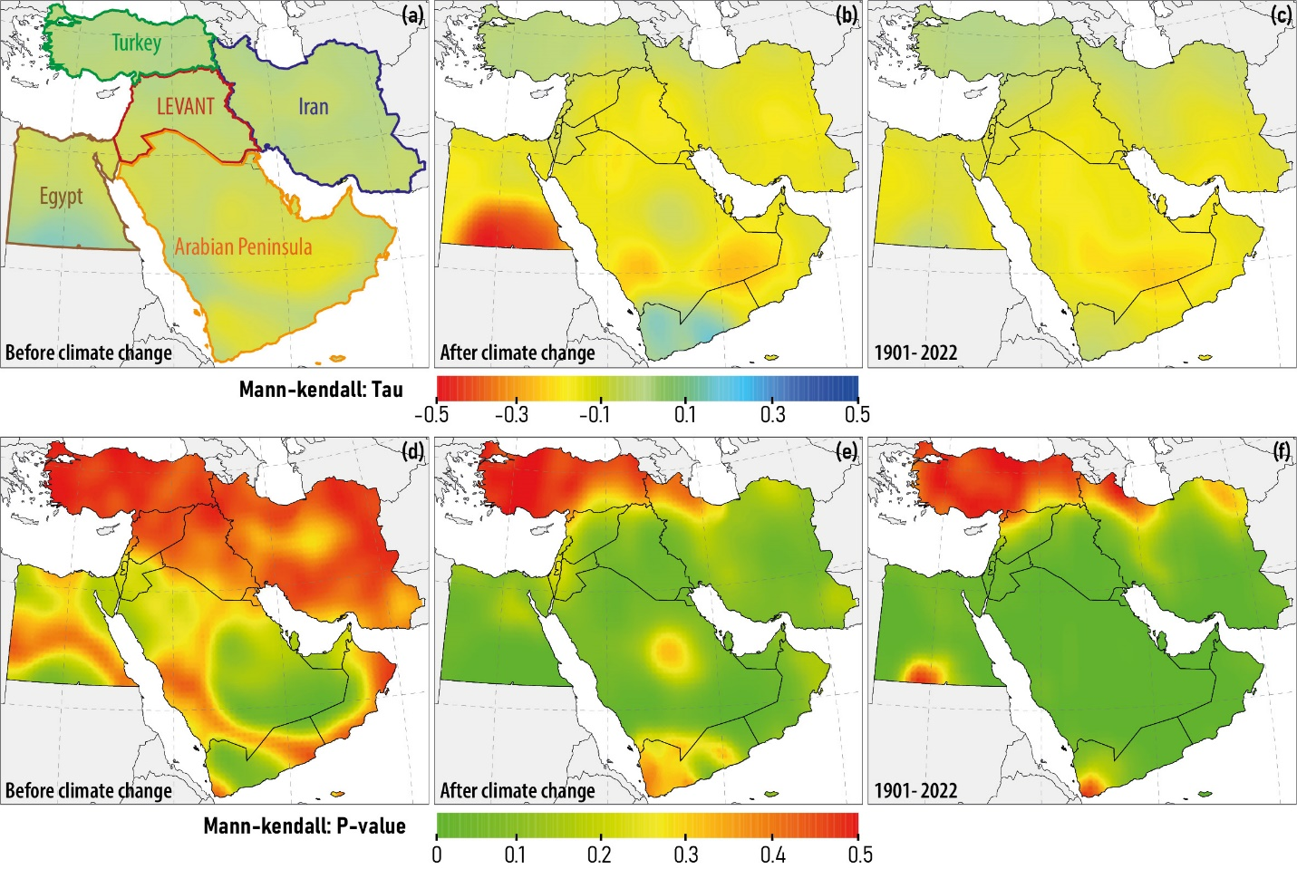
Fig. 2. Spatial changes in SPEI-derived meteorological drought trends in the Middle East before (a) and after (b) the climate change and the entire period 1901-2022 (c) and the statistical significance of these changes before (d) and after (e) the climate change and the entire period (f). The boundaries of the selected subregions (Table 1) for detailed spatiotemporal and statistical analysis in the study area (a).

3.2. Spatiotemporal variability of drought intensity
The frequency of occurrence of extreme values of the SPEI (SPEI < -2 and SPEI > +2) is generally lower than other SPEI levels across all subregions of the Middle East (Fig. 3). Overall, negative SPEI values (i.e., drought conditions) occur more frequently than positive SPEI values (i.e., wet conditions) throughout the study area. These spatial patterns indicate the predominance of dry conditions in the region.
Yemen has the highest frequency of extreme drought levels (SPEI < -2) compared to other subregions (Fig. 3-c). This is likely due to its arid climate, water scarcity, and specific climatic influences. In contrast, southern Iran, Yemen, northern Türkiye, and some areas of Saudi Arabia experience a higher frequency of very wet conditions (SPEI > +2) (Fig. 3-f). This pattern may be influenced by regional climate change, monsoon effects, and particular local meteorological characteristics (Song & Chung, 2024; Hamed et al., 2025). On the other hand, moderate SPEI levels (Fig. 3-a & d) are the most common in the region compared to other intensity levels. However, in southern Egypt, relatively wet conditions (Fig. 3-e) are most frequent, likely influenced by factors such as proximity to the Nile River and seasonal rainfall patterns.
In addition, areas with higher elevations or unique microclimates may experience a higher frequency of severe droughts (SPEI < -2) due to increased evapotranspiration and rainfall fluctuations. In contrast, areas with more temperate climates tend to have near-normal conditions (-1 < SPEI < +1), reflecting the influence of geographic and climatic variation on the spatial distribution of SPEI intensity levels across the Middle East.

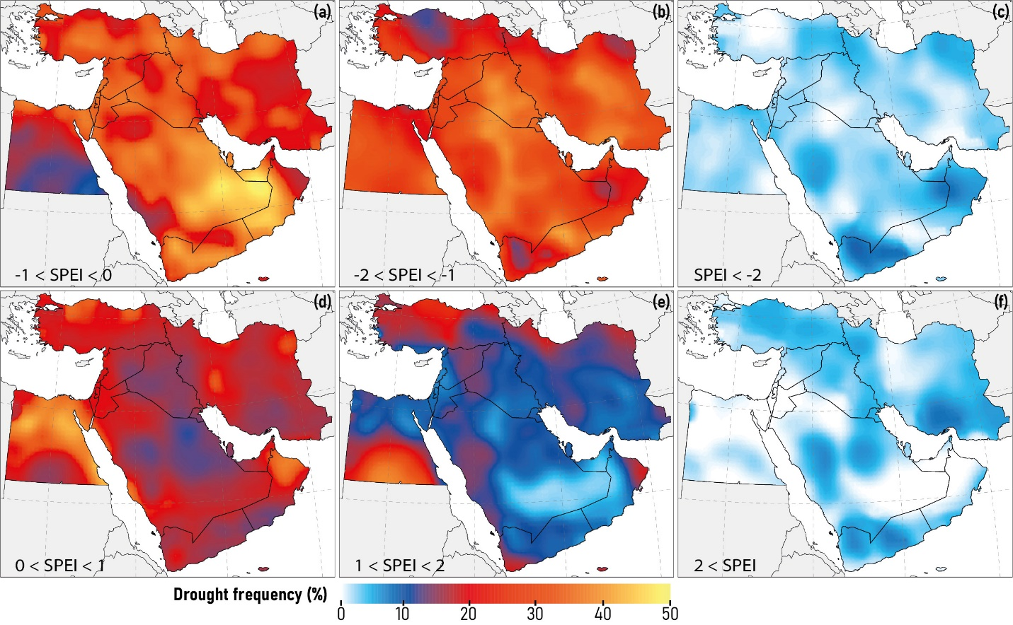
Fig. 3. Spatial analysis of different levels of meteorological drought intensity based on the SPEI for the period 1901-2022. The legend for each drought intensity level is placed in the lower left corner of the corresponding figure.

The percentage of annual area associated with six different drought intensity levels from SPEI < -2 to SPEI > +2 during the period 1901-2022 is shown in Fig. 4 with a color spectrum from red to blue in different subregions. In this way, SPEI values less than zero (corresponding to a yellow to red color spectrum) are interpreted as the occurrence of meteorological droughts of varying intensity. As shown in Fig. 4, the areas affected by different levels of drought have experienced an increasing trend in all subregions over the past century. Since 1970, the percentage of areas affected by drought (as indicated by SPEI < 0) has increased significantly in most subregions. In Iran, for example, the proportion of areas with SPEI < 0 has increased from about 30-40% in the decades before 1970 to more than 70% in some years after 2000. Similarly, in the Arabian Peninsula, nearly 80% of the region has been under drought conditions in recent years. In contrast, Türkiye, despite a similar trend, has experienced a smaller increase in drought-affected areas due to its relatively wetter climate and still has a higher percentage of regions with positive SPEI values compared to other subregions. Between 1970 and 2000, there was a noticeable change in trends in certain regions, particularly in Iran and the Levant. During this period, the proportion of areas experiencing positive SPEI values (moderate to high wet conditions) temporarily increased to about 40-50%. This change may be linked to the occurrence of wet periods or the impacts of climate cycles, such as El Niño-Southern Oscillation (ENSO) (Neelin et al., 2003; Singh et al., 2022). However, since the year 2000, the trend of increasing drought has not only intensified but also grown more severe. Notably, areas experiencing severe drought conditions (SPEI < -2), shown in red, expanded significantly in Iran, Egypt, and Saudi Arabia, affecting up to approximately 10% of the region in certain years. This evidence indicates that climate change has led to a simultaneous rise in both the prevalence and intensity of droughts across the Middle East.

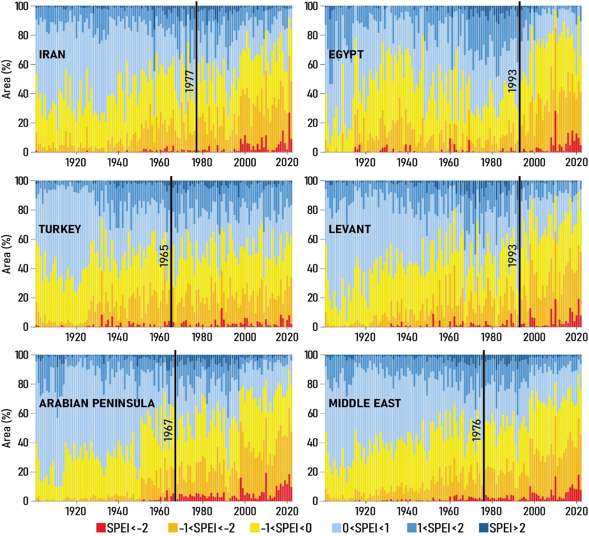
Fig. 4. Temporal analysis of the areas (%) affected by different levels of meteorological drought intensity based on SPEI during the period 1901-2022. Vertical black lines are the region-specific SPEI breakpoints (Table 2).

3.3. Changes in seasonal patterns of drought
Overall, the results of the Friedman test for the SPEI in the subregions show significant changes in the monthly patterns before and after climate change (Fig. 5). According to Table 3, in Iran, Egypt, the Levant, the Arabian Peninsula, and the entire Middle East, the difference between the months of the year (before and after climate change) was statistically significant (p-value < 0.05), indicating a serious impact of climate change on drought fluctuations in these regions. In contrast, only Türkiye did not show a significant change in the monthly pattern of SPEI before and after climate change, which may be related to its specific geography, northern altitudes, and greater climatic diversity compared to other subregions.
As shown in Table 3, the statistical analysis reveals that the most significant changes are occurring in Egypt, where the chi-square value has risen from 23.59 to 62.14. This indicates a significant increase in monthly fluctuations and a worsening of drought conditions, particularly during the dry months. The Levant also experienced a notable rise in the test statistic, from 25.27 to 45.21, signifying intensified climatic variability, especially in the dry months. In Iran, there is a relative decrease in the test statistic, which dropped from 27.34 to 22.39. This may suggest a reduction in monthly fluctuations, although the overall trend of drought persists. In the Arabian Peninsula, despite a decrease in the statistic from 44.91 to 20.34, a statistically significant difference remains, indicating a stabilization of dry conditions in this region.
Examination of the SPEI in different months shows that before climate change, the range of variation was greater in the spring and winter months, especially in regions such as Türkiye and Iran (Fig. 5), where seasonal precipitation plays an important role in the water balance. For example, in Türkiye, the SPEI range in March and April was reported to be up to about 2.5 units, indicating significant climatic variability. However, after climate change, the SPEI amplitude in the summer months (June, July, and August) decreased to less than 1 unit in most subregions, with a decrease of 40 to 50% in some subregions such as Egypt and the Levant. This decrease in amplitude, together with the low mean SPEI, indicates the dominance of uniform but more severe and persistent droughts.
The mean SPEI also tends to be more negative in most subregions after climate change, indicating an increase in the frequency and intensity of extreme droughts. In the summer months, the mean SPEI in most subregions has reached less than -1, which corresponds to severe drought. In regions such as Egypt, this value has fallen below -1.5. On the other hand, the decrease in the amplitude of fluctuations could indicate the disappearance of wet periods and the persistence of dry conditions. This trend, especially in drier regions such as the Arabian Peninsula and Egypt, indicates an increase in the occurrence of extreme droughts and a decrease in the likelihood of short-term improvement.
The results show that climate change is having a significant impact on the Middle East, characterized by reduced effective precipitation and increased seasonal temperatures. There has been a decrease in the amplitude of seasonal SPEI variability, as well as a decrease in its mean value (Fig. 5). As a result, the region is experiencing more severe and prolonged droughts, especially during the summer months. Not only has the SPEI decreased, but its positive variations have also become more limited. This trend indicates an increase in the frequency of extreme droughts in the region, which poses a serious threat to water resources, agriculture, and food security.

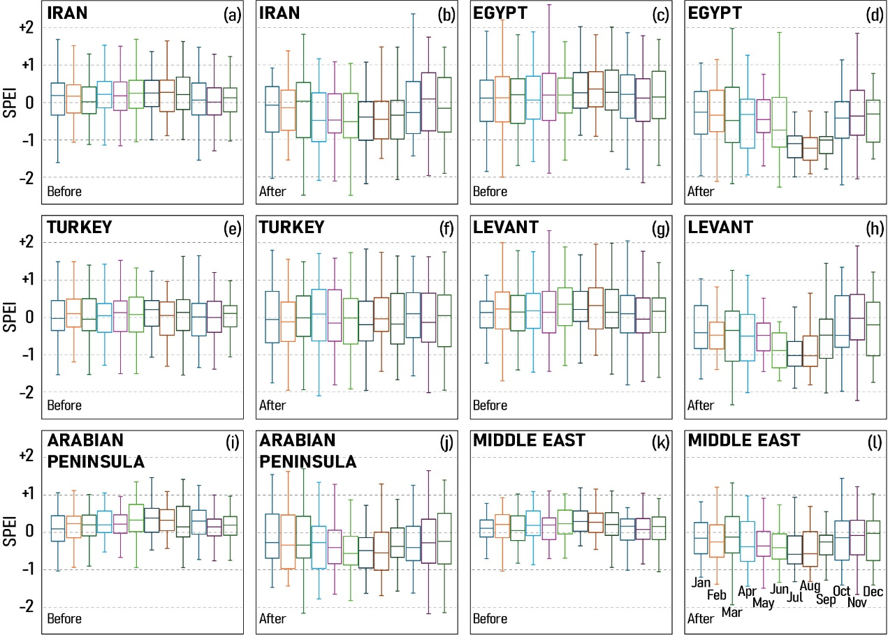
Fig. 5. Changes in monthly meteorological drought patterns in the Middle East subregions based on SPEI intensity analysis for the period 1901-2022.

Table 3. Statistical analysis of monthly patterns of meteorological drought changes based on SPEI intensity using the Friedman test (1901-2022).
Subregion | Before climate change (Chi-Square) | After climate change (Chi-Square)
Iran | 27.34* | 22.39*
Egypt | 23.59* | 62.14*
Türkiye | 5.39 | 5.25
Levant | 25.27* | 45.21*
Arabian Peninsula | 44.91* | 20.34*
Middle East | 42.16* | 46.41*
*Means p-value of the Friedman test is less than 0.05.

3.4. Drought return periods
Analysis of different return periods in various SPEI intensities in the subregions before and after climate change reveals important changes in drought occurrence patterns (Fig. 6). In subregions such as Iran and the Levant, the intensity of severe droughts in long-term return periods (more than 24 months) has increased by an average of 0.8 to 1.2 SPEI units after climate change. In the Levant, the intensity of droughts in the 36-month return period has increased from about -0.6 before climate change to about -1.4 afterwards, indicating profound changes in the climatic regime of this subregion. In contrast, in subregions such as western Türkiye and Egypt, this pattern is not uniform and in shorter periods (6–18 months), in some cases the intensity of droughts is higher before climate change, but in longer periods, the red curve (after the breakpoint) exceeds the blue curve (before the breakpoint) (Fig. 6).
To prevent the smoothing of drought behavior due to the use of temporal and spatial averages, 5th percentile analyses have also been employed to investigate changes in more severe and extreme droughts separately. This comparison shows that in many subregions, including Iran, the Arabian Peninsula, and the Levant, the difference between the 5th percentile curves and the mean is significant (Fig. 6). In Iran, during a 12-month return period, the drought intensity at the 5th percentile was approximately -0.9 SPEI units higher than the mean (Fig. 6-a & b). This difference suggests that while the average drought intensity may not show substantial changes, the likelihood of extreme droughts has increased significantly. This finding underscores the importance of conducting analyses based on extreme percentiles in drought risk management, particularly in the water and agricultural sectors.
A key part of result interpretation is using the bootstrapping method to estimate uncertainty. The shaded bands around regression curves indicate confidence limits derived from this technique. By applying random sampling, bootstrapping provides a more reliable distribution of drought severity across time (Fig. 6). This study attributes uncertainty to the natural variability of drought values across return periods and intra-regional climatic fluctuations. In regions like Türkiye and Egypt, where climate conditions are more volatile and spatial behavior is highly heterogeneous, the uncertainty band expands (up to ±0.4 SPEI units). This underscores the importance of localized analyses and region-specific policy decisions.
The intersection of the blue and red curves in certain regions, including Türkiye and Egypt, signals a shift in the temporal distribution of droughts. In Türkiye, for instance, drought severity is greater before climate change in shorter periods (e.g., 12 months), whereas the reverse occurs in longer periods. This pattern may stem from shifts in seasonal precipitation, reduced soil moisture, rising air temperatures, and variations in evapotranspiration. In some regions, land use/cover changes and excessive water exploitation have likely contributed to the intensification of extreme droughts (Darvishi Boloorani et al., 2024b). A combined analysis of the mean, lower percentiles, and uncertainty offers a more comprehensive and reliable view of drought trends across the Middle East.

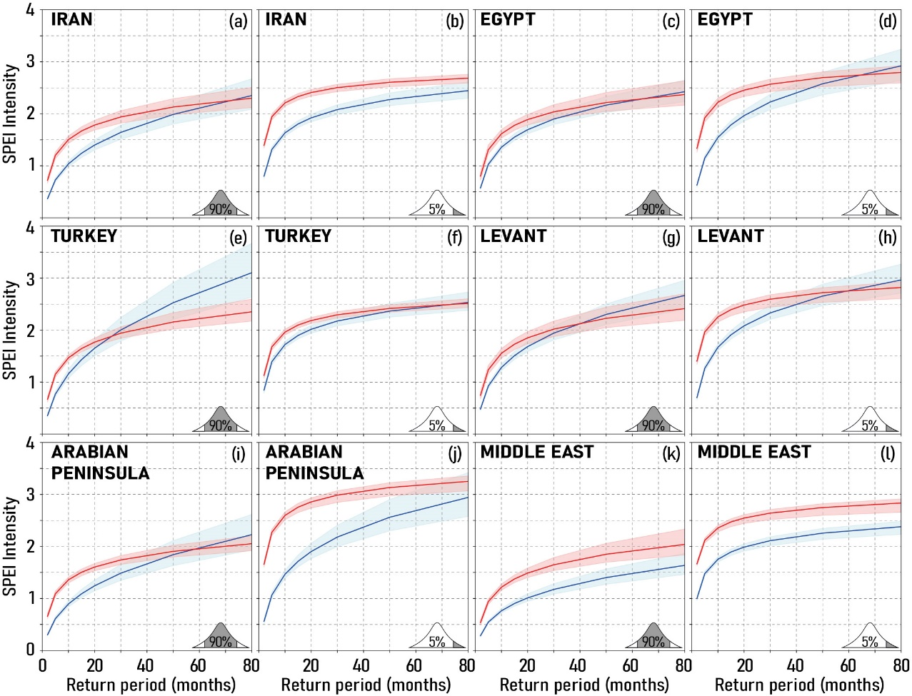
Fig. 6. Drought intensity-return period analysis for mean SPEI (a, c, e, g, i, and k) and 5th quantile SPEI (b, d, f, h, j, and l) in different subregions before and after climate change. Blue and red lines indicate data before and after climate change, respectively. Shaded areas represent the 5th and 95th percent confidence intervals. The vertical axis is the absolute value of the negative SPEI.

3.5. Changes in the duration and severity of droughts
Table 4 reveals a substantial increase in the average monthly duration of droughts across most subregions from 1901 to 2022. Egypt recorded the most significant rise, from 1.6 to 3 months (87.5%). In Iran, droughts extended from 1.5 to 2.2 months (46.7%), while the Levant saw an increase from 1.4 to 2.5 months (78.6%). The Arabian Peninsula also experienced a 56.3% rise, with durations growing from 1.6 to 2.5 months. Türkiye is the only subregion where the average drought duration has remained stable at 1.5 months, likely due to its distinct rainfall patterns and a comparatively lower influence of global climate change in the region.
The maximum duration of droughts has increased significantly, reflecting a trend toward longer dry periods (Table 4). In the Arabian Peninsula, the maximum duration increased from 4 to 13 months (225% increase). In Iran, the maximum duration increased from 5 to 10 months (100%), while in Egypt, the maximum duration increased from 6 to 10 months (66.7%). Even in Türkiye, where the average drought duration remained relatively stable, the maximum duration increased from 5 to 6 months (20%). Across the Middle East, the average maximum drought duration has increased from 4 to 13 months (a 225% rise), highlighting a significant intensification of long-term droughts. This trend is likely driven by declining effective rainfall, rising temperatures, and changes in rainfall patterns (Table 4).
Mean drought intensity increased sharply in most regions except Türkiye. Egypt experienced the largest increase (120%), from 2.5 to 5.5. The Arabian Peninsula experienced a 73.3% increase in intensity, from 3 to 5.2, while the Levant experienced an 80% increase, from 2.5 to 4.5. Iran also experienced a 61.5% increase, from 2.6 to 4.2. Even Türkiye, which remained relatively stable, witnessed a slight increase of 3.7% (Table 4). The maximum drought intensity has significantly increased, indicating a rise in extreme and critical drought events. In the Arabian Peninsula, the intensity has jumped from 9.6 to 29.7, which is an astounding 209% increase. Iran has experienced a rise from 9 to 23, a 155.6% increase, while the Levant has seen a 35.8% increase, moving from 16.2 to 22. Overall, across the Middle East, maximum drought intensity has surged from 6.9 to 28.8, marking a 317% increase. These figures underscore the necessity of analyzing not only averages but also extreme scenarios. The growing gap between average and maximum values highlights increasing variability and unpredictability, further emphasizing the importance of advanced statistical techniques such as extreme models and uncertainty simulations.

Table 4. Comparing changes in drought duration and intensity before and after climate change (1901-2022).
 |  | Subregion | Iran | Egypt | Türkiye | Levant | Arabian Peninsula | Middle East
Drought  duration  (month) | Mean | Before | 1.5 | 1.6 | 1.5 | 1.4 | 1.6 | 1.4
Drought  duration  (month) | Mean | After | 2.2 | 3.0 | 1.5 | 2.5 | 2.5 | 2.8
Drought  duration  (month) | Max | Before | 5 | 6 | 5 | 9 | 4 | 4
Drought  duration  (month) | Max | After | 10 | 10 | 6 | 11 | 13 | 13
Drought intensity | Mean | Before | 2.6 | 2.5 | 2.7 | 2.5 | 3.0 | 2.7
Drought intensity | Mean | After | 4.2 | 5.5 | 2.8 | 4.5 | 5.2 | 5.6
Drought intensity | Max | Before | 9.0 | 9.4 | 9.4 | 16.2 | 9.6 | 6.9
Drought intensity | Max | After | 23.0 | 18.8 | 11.9 | 22.0 | 29.7 | 28.8

3.6. Drought geographical expansion
This analysis presents the percentage of areas affected by drought across various subregions of the Middle East–Iran, Egypt, Türkiye, the Levant, and the Arabian Peninsula–during the period 1901 to 2022. The assessment is based on the SPEI and is categorized by season, including summer (June-July-August), autumn (September-October-November), winter (December-January-February), and spring (March-April-May), to understand seasonal variations in drought occurrence (Fig. 7).
As shown in Fig. 7, in most subregions–particularly Iran, Egypt, the Levant, and the Arabian Peninsula–the percentage of areas affected by drought has increased significantly in the 21st century. In Iran, summer (red line) has experienced a sharp rise since the early 2000s, reaching approximately 65% in 2022. Before 2000, however, spring (green line) and winter (blue line) sometimes exceeded summer drought levels, particularly in the 1970s and 1980s, when winter droughts were more severe in Iran and the Levant. Egypt followed a similar pattern, with summer drought intensity increasing rapidly from around 1995 onward, surpassing 65% in 2022. Previously, between the 1940s and 1960s, spring and autumn (green and yellow lines) occasionally exhibited higher drought impacts than other seasons. The Levant and the Arabian Peninsula showed a more balanced seasonal distribution between 1960 and 1990. However, since 2000, summer has become the dominant drought season. In contrast, Türkiye exhibits a different trend. The percentage of the area affected by drought has generally remained below 35%, with minimal seasonal variation. Even in recent years, the seasonal drought lines have remained close together, indicating a more stable climate with fewer severe seasonal droughts.
Between 1960 and 2000, drought conditions in most subregions, particularly Iran and the Arabian Peninsula, exhibited relative stability or even a slight decline. This phase, potentially influenced by natural climate variability–such as Pacific or North Atlantic oscillations–or regional water and agricultural policies, contrasts sharply with the post-2000 trend, which shows a pronounced increase in summer drought intensity. While summer has emerged as the most critical drought season in recent decades, historical data indicate that mid-20th-century droughts were occasionally more severe in other seasons. Understanding these seasonal variations is essential for climate analysis, water resource management, agriculture, and urban planning, helping to develop adaptive strategies for combating future drought conditions.

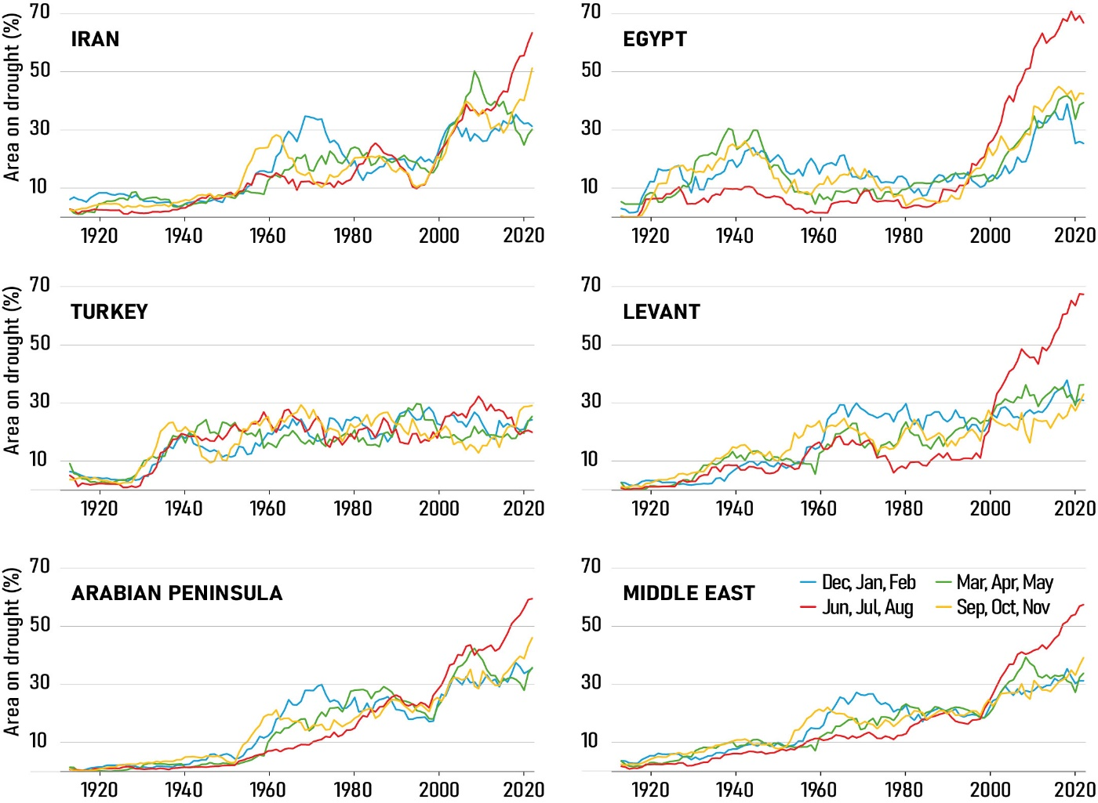
Fig. 7. Time series of the percentage of areas affected by drought (SPEI < -1) across the Middle East subregions, categorized by season, for the period 1901–2022.

3.7. Seasonal drought frequency change
The drought frequency change maps highlight distinct differences between the pre- and post-breakpoint periods across the four seasons in the Middle Eastern countries (Fig. 8). The most pronounced increase in drought frequency occurs in summer, with increases ranging from 30% to more than 60% in Saudi Arabia, central Iraq, southern Iran, UAE, and northwest Oman. This trend is also evident in Egypt, and parts of Yemen, where increases range from 20% to 40%. In contrast, Türkiye, Lebanon, and the Mediterranean coast show minimal changes, with some areas even experiencing a decrease in drought frequency (Fig. 8-b).
The upward trend in drought frequency is also evident in the spring, although less intense than in summer. Southern Saudi Arabia, some parts of Yemen and Oman, and parts of Iran have experienced increases ranging from 20% to 40%, while northern Iran and northern Iraq have experienced more moderate increases ranging from 10% to 30%. In contrast, northern areas such as Türkiye, the Caspian Sea coast, and parts of Syria exhibit minimal change, with some locations even showing a slight decrease in drought frequency ranging from 0% to 10% (Fig. 8-a). Autumn follows a similar pattern, albeit with less intensity, particularly in Saudi Arabia, Yemen, and southern Oman, where increases reach 20% to 40%, while northern regions show little to no significant change (Fig. 8-c).
Winter has exhibited the least change in drought frequency compared to other seasons. Most of Türkiye, Syria, northern Iraq, Lebanon, and the Mediterranean coast have remained relatively unchanged, with some areas even experiencing a slight decrease in drought frequency (0% to 10%). In contrast, regions such as southern Iran, northern Yemen, southern Oman, and parts of Saudi Arabia have experienced increases in drought frequency ranging from 10% to 30% (Fig. 8-d). Overall, the trend suggests that climate change has had the greatest impact on drought during the warmer seasons, particularly spring and summer. Countries in the southern and central parts of the Middle East, including Saudi Arabia, Iran, Iraq, UAE, Oman, and Yemen, have shown greater vulnerability to climate change, highlighting the need for targeted mitigation and adaptation strategies.
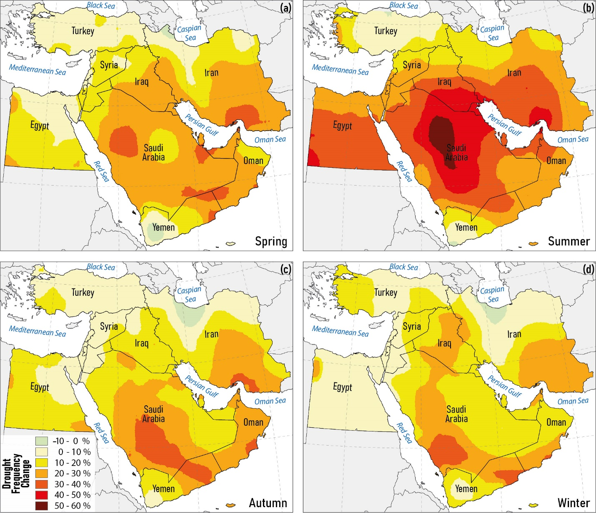
Fig. 8. Spatial variations in the seasonal frequency of meteorological droughts in spring (a), summer (b), autumn (c), and winter (d), as measured by SPEI, over the period 1901-2022.

3.8. Impact of precipitation and PET on SPEI trends
The trends of precipitation and PET, the main components of SPEI, before and after identified breakpoints in each subregion, along with their Kendall's τ values, are presented in Fig. 9. From an overall perspective, across the Middle East, PET consistently exceeds precipitation throughout the study period, confirming a persistent climatic water deficit. The mean aridity index (the ratio of precipitation to PET) (Arnold, 1992) for the Middle East is approximately 0.1, classifying the region overall as arid.
However, substantial spatial heterogeneity is evident. In Iran, the aridity index is 0.13 (arid), while Egypt exhibits a markedly lower value of 0.0085, indicating hyper-arid conditions. In contrast, Türkiye shows a considerably higher index of 0.57, corresponding to a dry sub-humid climate. The Levant has an aridity index of 0.11 (arid), whereas the Arabian Peninsula records 0.042, reflecting hyper-arid conditions. These pronounced differences in baseline aridity across subregions explain the spatial variability of SPEI responses, as the relative balance between precipitation and atmospheric evaporative demand governs drought severity, persistence, and trend behavior in each climatic setting.
In Iran, after the breakpoint in 1977, precipitation decreased (Kendall's τ = –0.225) while PET increased (Kendall's τ = 0.482), whereas prior to the breakpoint, PET exhibited a decreasing trend (Kendall's τ = –0.556). Consequently, both declining precipitation and increasing PET contributed to the decrease in SPEI in Iran after the breakpoint.
In Egypt, only PET showed an increasing trend after the breakpoint in 1993 (Kendall's τ = 0.32), which contributed to SPEI decline, while precipitation increased (Kendall's τ = 0.306), partially counteracting the SPEI decrease. This indicates that the increasing PET trend can outweigh the increasing precipitation trend, resulting in lower SPEI values and enhanced drought severity.
The trends in Turkey and the Levant are similar to Egypt; however, in Turkey, the post-breakpoint increase in precipitation after 1965 and in the Levant after 1993 were not statistically significant. In the Arabian Peninsula, precipitation trends before and after the breakpoint in 1967 were decreasing but not significant, while PET exhibited an increasing trend (Kendall's τ = 0.321), consistent with other subregions.
For the entire Middle East, PET decreased before the 1976 breakpoint but increased afterward (Kendall's τ = 0.580), driving the overall SPEI decline and intensification of drought. Overall, precipitation trends influenced SPEI in some subregions, such as Iran, but PET trends were consistently increasing after breakpoints across all subregions, significantly impacting drought conditions. This is particularly important for agricultural drought and crop yield, as increasing PET accelerates soil moisture loss and intensifies plant water stress. Even where precipitation is stable or rising, higher PET can reduce water availability for crops and increase irrigation demands. Policymakers should consider these trends in agricultural planning and drought mitigation strategies to maintain food security under changing climatic conditions.
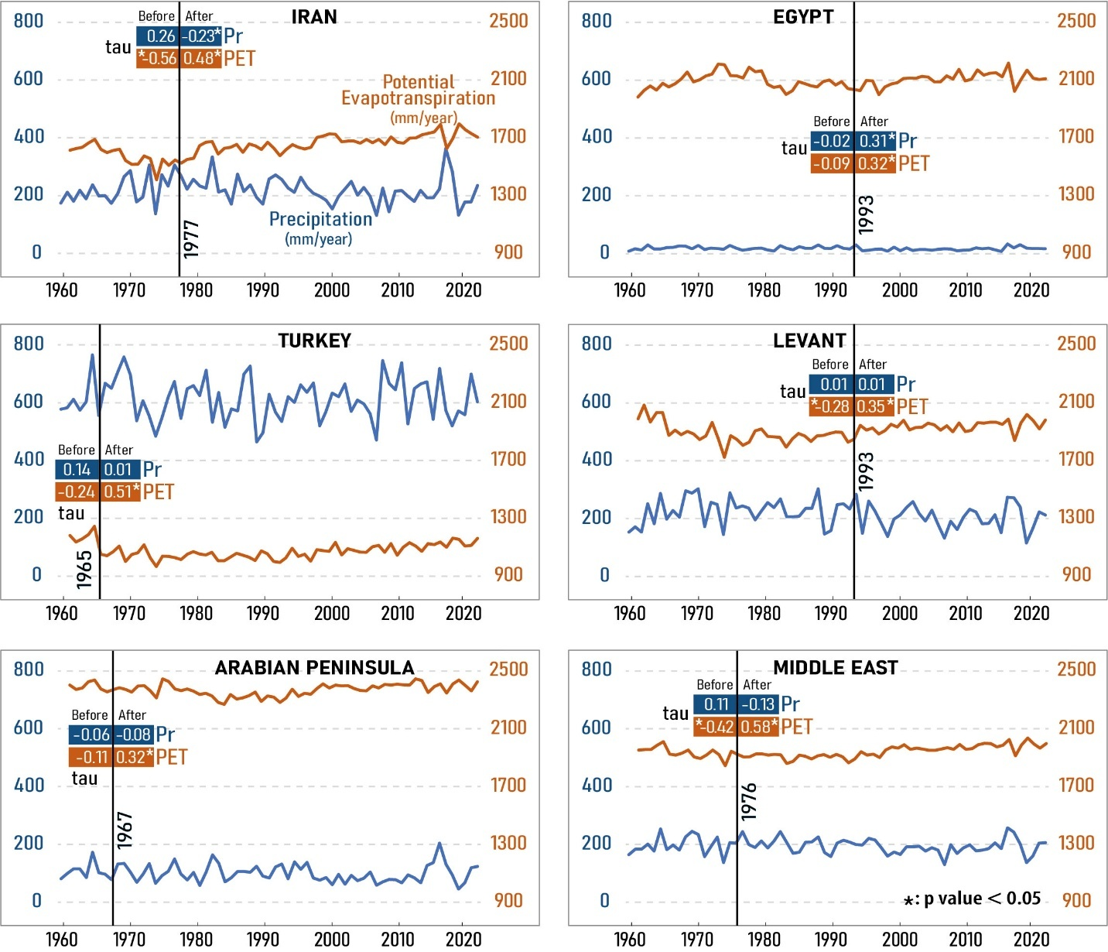
Fig. 9. Trend analysis of precipitation and potential evapotranspiration (PET) in different subregions before and after defined breakpoints.

3.9. Contextualization with previous regional and global studies
A comparison with previous regional studies highlights both consistencies and notable differences in drought characteristics across the Middle East. Earlier studies, such as Sharifikia (2013) and Mathbout et al. (2018), often relied on station-based observations and primarily employed precipitation-based indices such as SPI or focused on shorter temporal scales (e.g., 3–24 months). These studies generally reported strong spatial heterogeneity in drought patterns and emphasized region-specific drought regimes, particularly in the Eastern Mediterranean, reflecting the complex and highly variable hydroclimatic conditions of the region (Vicente-Serrano et al., 2010; Sheffield et al., 2012).
While our results are broadly consistent with these studies in terms of spatial variability and the general tendency toward increasing drought conditions, the magnitude and spatial extent of drought intensification are more pronounced in the present analysis. This difference can be largely attributed to methodological factors. In particular, the use of the Standardized Precipitation Evapotranspiration Index (SPEI) enables the explicit inclusion of atmospheric evaporative demand through potential evapotranspiration, which has been shown to significantly amplify drought signals under global warming conditions, particularly in arid and semi-arid regions (Vicente-Serrano et al., 2010; Dai, 2013; Beguería et al., 2014). In contrast, SPI-based approaches, which rely solely on precipitation, may underestimate drought severity under warming climates by neglecting temperature-driven increases in atmospheric water demand (Cook et al., 2020; IPCC, 2021).
Furthermore, differences in temporal coverage and data sources also contribute to discrepancies among studies. The present study employs a long-term gridded dataset (1901–2022), which enables the detection of multi-decadal variability and regime shifts, including breakpoint behavior that cannot be resolved using shorter observational records. In contrast, many previous studies are constrained by shorter time periods and uneven station networks, which may limit their ability to capture long-term hydroclimatic changes at regional scales (Hersbach et al., 2020; IPCC, 2021). Additionally, variations in drought definitions and threshold selection can influence reported drought frequency and intensity, particularly when comparing SPI- and SPEI-based approaches under non-stationary climatic conditions. These methodological differences should be carefully considered when comparing drought assessments across studies. They also underscore the importance of using temperature-sensitive drought indices and long-term, spatially continuous datasets for a more robust and physically consistent characterization of drought dynamics under climate change in the Middle East.
Overall, despite these methodological differences, our results are consistent with the broader regional and global consensus that drought frequency, duration, and intensity have increased in recent decades, particularly under the influence of rising temperatures and enhanced atmospheric evaporative demand. A large body of evidence indicates that increasing evaporative demand associated with global warming is a key mechanism intensifying drought conditions, especially in arid and semi-arid regions such as the Middle East (Vicente-Serrano et al., 2010; Beguería et al., 2014).
At the global scale, assessment reports and observational studies consistently show that rising temperatures have led to higher atmospheric water demand, which can intensify drought severity even in regions where precipitation trends are weak or spatially heterogeneous (IPCC, 2021). This demonstrates that drought intensification is not solely controlled by precipitation deficits, but is strongly modulated by atmospheric evaporative demand, which acts as a dominant driver under warming conditions.
At the regional scale, studies focusing on the Middle East and North Africa have also documented significant increases in drought severity and spatial extent over recent decades, largely driven by warming-induced increases in evapotranspiration rather than uniform decreases in precipitation (Zittis et al., 2022). These findings are strongly consistent with the results of this study, reinforcing the conclusion that temperature-driven processes play a central role in recent drought intensification across the Middle East.

3.10. Limitation and future work
This study provides a comprehensive spatiotemporal assessment of drought characteristics across the Middle East using the SPEI drought index; however, several limitations should be acknowledged. First, the analysis is based on a global SPEI product with an approximate spatial resolution of 55 km. While appropriate for regional-scale investigations, this resolution may obscure local hydroclimatic heterogeneity and introduce spatial uncertainty, particularly in areas with complex topography or strong climatic gradients. Future research should incorporate station-based observational precipitation and temperature records to enable higher-resolution validation and local-scale assessments. Nevertheless, the limited density of meteorological stations, uneven spatial distribution, and restricted accessibility of national datasets remain practical constraints that must be addressed through improved data-sharing frameworks.
Second, the present study primarily examined meteorological drought variability as represented by SPEI-1, with emphasis on climate-driven changes. However, drought severity, especially agricultural and hydrological drought, is influenced not only by climatic variability but also by anthropogenic factors such as groundwater extraction, irrigation expansion, land-use change, and reservoir regulation. Disentangling the relative contributions of climate forcing and human intervention is essential for a mechanistic understanding of drought intensification in the region. Future studies should therefore integrate socio-hydrological variables and water management indicators to quantify the combined and potentially interacting effects of climate change and human activities.
Finally, the exclusive focus on the one-month timescale limits insight into drought propagation processes. While SPEI-1 effectively captures short-term meteorological anomalies, longer accumulation periods (e.g., 3- and 6-month scales) are better suited for assessing agricultural and hydrological drought responses. A multi-timescale framework would allow investigation of cross-scale linkages and their impacts on soil moisture, water bodies, and agricultural systems, thereby providing a more comprehensive characterization of drought dynamics in the Middle East.

4. Conclusion
This study presents a comprehensive assessment of meteorological drought variability across the Middle East during 1901–2022 using the Standardized Precipitation–Evapotranspiration Index (SPEI). A major regional breakpoint was detected around 1976, indicating a transition toward more frequent, prolonged, and intense drought conditions. Although breakpoint timing varies among subregions, occurring earlier in Türkiye (1965) and later in Egypt and the Levant (1993), the dominant regional signal is a post-breakpoint intensification of drought severity. Spatially, the strongest decline in SPEI values is observed in southern Egypt and the southeastern and southwestern Arabian Peninsula, while parts of Yemen show localized reductions in drought severity. Türkiye and Mediterranean coastal areas exhibit comparatively stable trends, likely influenced by topographic controls and snow-water storage buffering effects.
The spatial extent of drought-affected areas has expanded markedly in the 21st century, with summer emerging as the most vulnerable season. Drought frequency has increased by up to 60% in Saudi Arabia, central Iraq, southern Iran, the UAE, and Oman, while Egypt, Yemen, and Syria also show substantial growth in affected areas. In contrast, Türkiye and Mediterranean regions display relatively stable or slightly declining drought frequencies. Drought duration and intensity have also intensified: maximum duration increased from 1.6 to 3 months in Egypt (87.5%), and by 46.7%, 78.6%, and 56.3% in Iran, the Levant, and the Arabian Peninsula, respectively. Maximum drought intensity increased by 209% in the Arabian Peninsula, 155.6% in Iran, and 35.8% in the Levant. These findings confirm a systematic shift toward longer and more severe drought episodes across arid and semi-arid subregions.
Trend decomposition indicates that post-breakpoint drought intensification is primarily driven by significant increases in PET across all subregions, whereas precipitation trends exhibit weaker or spatially heterogeneous changes. This result demonstrates that temperature-driven atmospheric evaporative demand is the dominant mechanism amplifying drought severity in the Middle East.
Given these spatially differentiated dynamics, adaptation strategies must be region-specific. In Egypt and the Arabian Peninsula, where drought duration and intensity have increased most sharply, priority should be given to demand-side water management, expansion of treated wastewater reuse, improvement of irrigation efficiency (e.g., deficit and precision irrigation), and revision of cropping calendars to reduce peak summer water demand. In Iran and the Levant, where both intensity and duration have risen substantially, integrated watershed management, groundwater abstraction control, and drought-resilient crop diversification are critical. In contrast, Türkiye and Mediterranean coastal regions, which show relatively stable trends, should prioritize proactive snowpack monitoring, reservoir optimization, and early warning systems to maintain resilience against emerging warming-driven PET increases.
Overall, the findings demonstrate that climate change has fundamentally altered drought regimes in the Middle East, primarily through enhanced evaporative demand rather than uniform precipitation decline. The strong post-1976 intensification, particularly in summer, poses escalating risks to water security, food production, and socio-economic stability. Future research should further quantify the relative contributions of atmospheric circulation variability, land-use change, and anthropogenic water management to regional drought amplification, thereby supporting the development of physically grounded and spatially targeted adaptation policies.

5. Acknowledgments
The authors appreciate the financial support of the Iran National Science Foundation (INSF) (Project No. 4021582), the National Key R&D Program of China (2023YFE0102500), and the National Science Foundation of China (42361144711) for conducting this research.

6. References
Abatzoglou, J. T., Dobrowski, S. Z., Parks, S. A., & Hegewisch, K. C. (2018). TerraClimate, a high-resolution global dataset of monthly climate and climatic water balance from 1958–2015. Scientific data, 5(1), 170191.‏ https://doi.org/10.1038/sdata.2017.191
Adams, R. P., & MacKay, D. J. C. (2007). Bayesian online changepoint detection. ArXiv Preprint ArXiv:0710.3742.
AghaKouchak, A., Mirchi, A., Madani, K., Di Baldassarre, G., Nazemi, A., Alborzi, A., Anjileli, H., Azarderakhsh, M., Chiang, F., Hassanzadeh, E., Huning, L. S., Mallakpour, I., Martinez, A., Mazdiyasni, O., Moftakhari, H., Norouzi, H., Sadegh, M., Sadeqi, D., Van Loon, A. F., & Wanders, N. (2021). Anthropogenic Drought: Definition, Challenges, and Opportunities. Reviews of Geophysics, 59(2). https://doi.org/10.1029/2019RG000683
Akbari, M., Mirchi, A., Roozbahani, A., Gafurov, A., Kløve, B., & Haghighi, A. T. (2022). Desiccation of the Transboundary Hamun Lakes between Iran and Afghanistan in Response to Hydro-climatic Droughts and Anthropogenic Activities. Journal of Great Lakes Research, 48(4), 876–889. https://doi.org10.1016/j.jglr.2022.05.004
Al-Dousari, A., Pye, K., Al-Hazza, A., Al-Shatti, F., Ahmed, M., Al-Dousari, N., & Rajab, M. (2020). Nanosize inclusions as a fingerprint for aeolian sediments. Journal of Nanoparticle Research, 22(5), 94.
Al-Dousari, A., Omar, A., Al-Hemoud, A., Aba, A., Alrashedi, M., Alrawi, M., ... & William, T. (2022). A success story in controlling sand and dust storms hotspots in the Middle East. Atmosphere, 13(8), 1335.
Al-Hemoud, A., Al-Enezi, A., Al-Dashti, H., Petrov, P., Misak, R., AlSaraf, M., & Malek, M. (2023). Hazard Assessment and Hazard Mapping for Kuwait. International Journal of Disaster Risk Science, 1–19.
Alahacoon, N., & and Edirisinghe, M. (2022). A comprehensive assessment of remote sensing and traditional based drought monitoring indices at global and regional scale. Geomatics, Natural Hazards and Risk, 13(1), 762–799. https://doi.org/10.1080/19475705.2022.2044394
Alexandersson, H. (1986). A homogeneity test applied to precipitation data. Journal of Climatology, 6(6), 661–675. https://doi.org/10.1002/joc.3370060607
Almazroui, M., Halwani, H. A., Islam, M. N., Ghulam, A. B. S., & Hantoush, A. S. (2022). Regional and seasonal variation of climate extremes over Saudi Arabia: observed evidence for the period 1978–2021. Arabian Journal of Geosciences, 15(20), 1605. https://doi.org/10.1007/s12517-022-10882-0
Apurv, T., Sivapalan, M., & Cai, X. (2017). Understanding the role of climate characteristics in drought propagation. Water Resources Research, 53(11), 9304–9329.
Arnold, E. (1992). World atlas of desertification. UNEP: London, UK.‏
Bayram, H., & Öztürk, A. B. (2021). Global Climate Change, Desertification, and Its Consequences in Turkey and the Middle East (K. E. Pinkerton & W. N. Rom (eds.); pp. 445–458). Springer International Publishing. https://doi.org/10.1007/978-3-030-54746-2_21
Beguería, S., Vicente‐Serrano, S. M., Reig, F., & Latorre, B. (2014). Standardized precipitation evapotranspiration index (SPEI) revisited: parameter fitting, evapotranspiration models, tools, datasets and drought monitoring. International Journal of Climatology, 34(10), 3001–3023.
Beguería, S., Vicente Serrano, S. M., Reig-Gracia, F., & Latorre Garcés, B. (2023). SPEIbase v. 2.9 [Dataset]. https://doi.org/10.20350/digital CSIC/15470
Ciftci, N. D., & Sahin, A. D. (2023). Temperature and precipitation extremes’ variability in Turkey. Meteorology and Atmospheric Physics, 135(4), 40. https://doi.org/10.1007/s00703-023-00976-z
Cook, B. I., Mankin, J. S., Marvel, K., Williams, A. P., Smerdon, J. E., & Anchukaitis, K. J. (2020). Twenty‐first century drought projections in the CMIP6 forcing scenarios. Earth's Future, 8(6), e2019EF001461.
Dai, A., Zhao, T., & Chen, J. (2018). Climate Change and Drought: a Precipitation and Evaporation Perspective. Current Climate Change Reports, 4(3), 301–312. https://doi.org/10.1007/s40641-018-0101-6
Dai, A. (2013). Increasing drought under global warming in observations and models. Nature climate change, 3(1), 52-58.
Darvishi Boloorani, A., Nasiri, N., Soleimani, M., Papi, R., Neysani Samany, N., Amiri, F., & Al-Hemoud, A. (2024c). Climate Change, Dust Storms, and Air Pollution in the MENA Region BT - Climate Change and Environmental Degradation in the MENA Region (A. Al-Quraishi, A. Negm, & B. Benzougagh (eds.); pp. 327–343). Springer Nature Switzerland. https://doi.org/10.1007/698_2024_1144
Darvishi Boloorani, A., Papi, R., Soleimani, M., Karami, L., Amiri, F., & Neysani Samany, N. (2021). Water bodies changes in Tigris and Euphrates basin has impacted dust storms phenomena. Aeolian Research, 50, 100698.
Darvishi Boloorani, A., Soleimani, M., Neysani Samany, N., Papi, R., Nasiri, N., Amiri, F., Mirzaei, S., & Al-Hemoud, A. (2024b). Climate Change, Drought, and Water Scarcity in the MENA Region BT - Climate Change and Environmental Degradation in the MENA Region (A. Al-Quraishi, A. Negm, & B. Benzougagh (eds.); pp. 189–204). Springer Nature Switzerland. https://doi.org/10.1007/698_2024_1143
Darvishi Boloorani, A., Soleimani, M., Papi, R., Nasiri, N., Neysani Samany, N., Mirzaei, S., & Al-Hemoud, A. (2024a). Assessing the role of drought in dust storm formation in the Tigris and Euphrates basin. Science of The Total Environment, 921, 171193. https://doi.org /10.1016/j.scitotenv.2024.171193
Dong, B., Aksenov, Y., Colfescu, I., Harvey, B., Hirschi, J., Josey, S., Lu, H., Mecking, J., Oltmanns, M., Osprey, S., Robson, J., Rynders, S., Shaffrey, L., Sinha, B., Sutton, R., & Weisheimer, A. (2025). Key drivers of large scale changes in North Atlantic atmospheric and oceanic circulations and their predictability. Climate Dynamics, 63(2), 113. https://doi.org/10.1007/s00382-025-07591-1
Efron, B. (1992). Bootstrap Methods: Another Look at the Jackknife (S. Kotz & N. L. Johnson (eds.); pp. 569–593). Springer New York. https://doi.org/10.1007/978-1-4612-4380-9_41
Ejaz, N., & Bahrawi, J. (2022). Assessment of Drought Severity and Their Spatio-Temporal Variations in the Hyper Arid Regions of Kingdom of Saudi Arabia: A Case Study from Al-Lith and Khafji Watersheds. Atmosphere, 13(8), 1264.
Fadhil, A. M. (2011). Drought mapping using Geoinformation technology for some sites in the Iraqi Kurdistan region. International Journal of Digital Earth, 4(3), 239–257.
Friedman, M. (1937). The use of ranks to avoid the assumption of normality implicit in the analysis of variance. Journal of the American Statistical Association, 32(200), 675–701.
Gond, S., Gupta, N., Dikshit, P. K. S., & Patel, J. (2023a). Assessment of drought variability using SPEI under observed and projected climate scenarios over Uttar Pradesh, India. Physics and Chemistry of the Earth, Parts A/B/C, 131, 103440.‏ https://doi.org/10.1016/j.pce.2023.103440
Gond, S., Gupta, N., Patel, J., & Dikshit, P. K. S. (2023b). Spatiotemporal evaluation of drought characteristics based on standard drought indices at various timescales over Uttar Pradesh, India. Environmental Monitoring and Assessment, 195(3), 439.‏ https://doi.org/10.1007/s10661-023-10988-2
Gond, S., Agnihotri, A. K., Gupta, N., & Dikshit, P. K. S. (2025). Comprehensive analysis of characteristics of dry–wet events and their transitions in Uttar Pradesh, India. Water Science and Engineering, 18(1), 59-68.‏ https://doi.org/10.1016/j.wse.2024.06.003
Hagenlocher, M., Meza, I., Anderson, C. C., Min, A., Renaud, F. G., Walz, Y., Siebert, S., & Sebesvari, Z. (2019). Drought vulnerability and risk assessments: state of the art, persistent gaps, and research agenda. Environmental Research Letters, 14(8), 83002. https://doi.org/10.1088/1748-9326/ab225d
Haile, G. G., Tang, Q., Hosseini‐Moghari, S., Liu, X., Gebremicael, T. G., Leng, G., Kebede, A., Xu, X., & Yun, X. (2020). Projected impacts of climate change on drought patterns over East Africa. Earth’s Future, 8(7), e2020EF001502.
Hamed, K. H., & Ramachandra Rao, A. (1998). A modified Mann-Kendall trend test for autocorrelated data. Journal of Hydrology, 204(1–4), 182–196. https://doi.org/10.1016/S0022-1694(97)00125-X
Hamed, M. M., Ullah, S., Jasim Al-Hasani, A. A., Nashwan, M. S., & Shahid, S. (2025). Rising Threats of Compound Droughts and Heatwaves in MENA: Implications for Population and Agriculture under Paris Agreement Scenarios. Earth Systems and Environment. https://doi.org/10.1007/s41748-025-00575-5
Han, J., & Singh, V. P. (2023). A review of widely used drought indices and the challenges of drought assessment under climate change. Environmental Monitoring and Assessment, 195(12), 1438. https://doi.org/10.1007/s10661-023-12062-3
He, B., Chang, J., Wang, Y., Wang, Y., Zhou, S., & Chen, C. (2021). Spatio-temporal evolution and non-stationary characteristics of meteorological drought in inland arid areas. Ecological Indicators, 126, 107644. https://doi.org/10.1016/j.ecolind.2021.107644
Hersbach, H., Bell, B., Berrisford, P., Hirahara, S., Horányi, A., Muñoz‐Sabater, J., ... & Thépaut, J. N. (2020). The ERA5 global reanalysis. Quarterly journal of the royal meteorological society, 146(730), 1999-2049.
Hu, H.-M., Trouet, V., Spötl, C., Tsai, H.-C., Chien, W.-Y., Sung, W.-H., Michel, V., Yu, J.-Y., Valensi, P., Jiang, X., Duan, F., Wang, Y., Mii, H.-S., Chou, Y.-M., Lone, M. A., Wu, C.-C., Starnini, E., Zunino, M., Watanabe, T. K., … Shen, C.-C. (2022). Tracking westerly wind directions over Europe since the middle Holocene. Nature Communications, 13(1), 7866. https://doi.org/10.1038/s41467-022-34952-9
IPCC. (2021). Climate Change 2021: The Physical Science Basis. Cambridge University Press.
Kömüşcü, A. Ü., & Aksoy, M. (2023). Long-term spatio-temporal trends and periodicities in monthly and seasonal precipitation in Turkey. Theoretical and Applied Climatology, 151(3–4), 1623–1649. https://doi.org/10.1007/s00704-022-04349-1
Kushwaha, N. L., Elbeltagi, A., Patel, A., Zakwan, M., Rajput, J., & Sharma, P. (2022). Chapter 6 - Assessment of water resources using remote sensing and GIS techniques. In M. Zakwan, A. Wahid, M. Niazkar, & U. B. T.-C. D. in W. S. R. Chatterjee (Eds.), Water Resource Modeling and Computational Technologies (Vol. 7, pp. 85–98). Elsevier. https://doi.org/10.1016/B978-0-323-91910-4.00006-6
Kuwayama, Y., Thompson, A., Bernknopf, R., Zaitchik, B., & Vail, P. (2019). Estimating the impact of drought on agriculture using the US Drought Monitor. American Journal of Agricultural Economics, 101(1), 193–210.
Lelieveld, J., Hadjinicolaou, P., Kostopoulou, E., Chenoweth, J., El Maayar, M., Giannakopoulos, C., Hannides, C., Lange, M. A., Tanarhte, M., Tyrlis, E., & Xoplaki, E. (2012). Climate change and impacts in the Eastern Mediterranean and the Middle East. Climatic Change, 114(3), 667–687. https://doi.org/10.1007/s10584-012-0418-4
Linke, A. M., Witmer, F. D. W., O’Loughlin, J., McCabe, J. T., & Tir, J. (2018). The consequences of relocating in response to drought: human mobility and conflict in contemporary Kenya. Environmental Research Letters, 13(9), 94014.
Mann, H. B. (1945). Nonparametric Tests Against Trend. Econometrica, 13(3), 245. https://doi.org/10.2307/1907187
Mathbout, S., Lopez-Bustins, J. A., Martin-Vide, J., Bech, J., & Rodrigo, F. S. (2018). Spatial and temporal analysis of drought variability at several time scales in Syria during 1961–2012. Atmospheric Research, 200, 153–168. https://doi.org/10.1016/j.atmosres.2017.09.016
Mishra, A. K., & Singh, V. P. (2010). A review of drought concepts. Journal of Hydrology, 391(1), 202–216. https://doi.org/10.1016/j.jhydrol.2010.07.012
Müller, L. M., & Bahn, M. (2022). Drought legacies and ecosystem responses to subsequent drought. Global Change Biology, 28(17), 5086–5103.
Neelin, J. D., Chou, C., & Su, H. (2003). Tropical drought regions in global warming and El Niño teleconnections. Geophysical Research Letters, 30(24). https://doi.org/10.1029/2003GL018625
Nwayor, I. J., & Robeson, S. M. (2024). Exploring the relationship between SPI and SPEI in a warming world. Theoretical and Applied Climatology, 155(4), 2559–2569. https://doi.org/10.1007/s00704-023-04764-y
Ouarda, T. B. M. J., & Charron, C. (2019). Changes in the distribution of hydro-climatic extremes in a non-stationary framework. Scientific Reports, 9(1), 8104. https://doi.org/10.1038/s41598-019-44603-7
Pettitt, A. N. (1979). A non‐parametric approach to the change‐point problem. Journal of the Royal Statistical Society: Series C (Applied Statistics), 28(2), 126–135.
Reiss, R.-D., Thomas, M., & Reiss, R. D. (1997). Statistical analysis of extreme values (Vol. 2). Springer.
Salimi, H., Asadi, E., & Darbandi, S. (2021). Meteorological and hydrological drought monitoring using several drought indices. Applied Water Science, 11, 1–10.
Schwalm, C. R., Anderegg, W. R. L., Michalak, A. M., Fisher, J. B., Biondi, F., Koch, G., Litvak, M., Ogle, K., Shaw, J. D., Wolf, A., Huntzinger, D. N., Schaefer, K., Cook, R., Wei, Y., Fang, Y., Hayes, D., Huang, M., Jain, A., & Tian, H. (2017). Global patterns of drought recovery. Nature, 548(7666), 202–205. https://doi.org/10.1038/nature23021
Sharafi, S., & Ghaleni, M. M. (2022). Spatial assessment of drought features over different climates and seasons across Iran. Theoretical and Applied Climatology, 147(3), 941–957. https://doi.org/10.1007/s00704-021-03853-0
Sharifikia, M. (2013). Environmental challenges and drought hazard assessment of Hamoun Desert Lake in Sistan region, Iran, based on the time series of satellite imagery. Natural Hazards, 65(1), 201–217.
Sheffield, J., Wood, E. F., & Roderick, M. L. (2012). Little change in global drought over the past 60 years. Nature, 491(7424), 435-438.
Singh, J., Ashfaq, M., Skinner, C. B., Anderson, W. B., Mishra, V., & Singh, D. (2022). Enhanced risk of concurrent regional droughts with increased ENSO variability and warming. Nature Climate Change, 12(2), 163–170. https://doi.org/10.1038/s41558-021-01276-3
Song, Y. H., & Chung, E.-S. (2024). Uncertainties in Future Extreme Drought Characteristics Associated with SSP Scenarios over Global Lands. Earth Systems and Environment. https://doi.org/10.1007/s41748-024-00505-x
Soylu Pekpostalci, D., Tur, R., Danandeh Mehr, A., Vazifekhah Ghaffari, M. A., Dąbrowska, D., & Nourani, V. (2023). Drought Monitoring and Forecasting across Turkey: A Contemporary Review. In Sustainability (Vol. 15, Issue 7). https://doi.org/10.3390/su15076080
Tabari, H., Nikbakht, J., & Hosseinzadeh Talaee, P. (2013). Hydrological Drought Assessment in Northwestern Iran Based on Streamflow Drought Index (SDI). Water Resources Management, 27(1), 137–151. https://doi.org/10.1007/s11269-012-0173-3
Van Loon, A. F. (2015). Hydrological drought explained. Wiley Interdisciplinary Reviews: Water, 2(4), 359–392.
Van Loon, A. F., Gleeson, T., Clark, J., Van Dijk, A. I. J. M., Stahl, K., Hannaford, J., Di Baldassarre, G., Teuling, A. J., Tallaksen, L. M., Uijlenhoet, R., Hannah, D. M., Sheffield, J., Svoboda, M., Verbeiren, B., Wagener, T., Rangecroft, S., Wanders, N., & Van Lanen, H. A. J. (2016). Drought in the Anthropocene. Nature Geoscience, 9(2), 89–91. https://doi.org/10.1038/ngeo2646
Vicente-Serrano, S. M., Beguería, S., & López-Moreno, J. I. (2010). A multiscalar drought index sensitive to global warming: the standardized precipitation evapotranspiration index. Journal of Climate, 23(7), 1696–1718.
Vicente-Serrano, S. M., Quiring, S. M., Peña-Gallardo, M., Yuan, S., & Domínguez-Castro, F. (2020). A review of environmental droughts: Increased risk under global warming? Earth-Science Reviews, 201, 102953. https://doi.org/10.1016/j.earscirev.2019.102953
Vieira, M. J. F., & Stadnyk, T. A. (2023). Leveraging global climate models to assess multi-year hydrologic drought. Npj Climate and Atmospheric Science, 6(1), 179. https://doi.org/10.1038/s41612-023-00496-y
Volpi, E., Fiori, A., Grimaldi, S., Lombardo, F., & Koutsoyiannis, D. (2015). One hundred years of return period: Strengths and limitations. Water Resources Research, 51(10), 8570–8585. https://doi.org/10.1002/2015WR017820
Von Neumann, J. (1941). Distribution of the ratio of the mean square successive difference to the variance. The Annals of Mathematical Statistics, 12(4), 367–395.
Wang, M., Jiang, S., Ren, L., Xu, C.-Y., Menzel, L., Yuan, F., Xu, Q., Liu, Y., & Yang, X. (2021). Separating the effects of climate change and human activities on drought propagation via a natural and human-impacted catchment comparison method. Journal of Hydrology, 603, 126913. https://doi.org/10.1016/j.jhydrol.2021.126913
Xie, P., Gu, H., Sang, Y.-F., Wu, Z., & Singh, V. P. (2019). Comparison of different methods for detecting change points in hydroclimatic time series. Journal of Hydrology, 577, 123973. https://doi.org/10.1016/j.jhydrol.2019.123973
Zhang, Q., Miao, C., Su, J., Gou, J., Hu, J., Zhao, X., & Xu, Y. (2025). A new high-resolution multi-drought-index dataset for mainland China. Earth System Science Data, 17(3), 837–853. https://doi.org/10.5194/essd-17-837-2025
Zhao, R., Sun, H., Xing, L., Li, R., & Li, M. (2023). Effects of anthropogenic climate change on the drought characteristics in China: From frequency, duration, intensity, and affected area. Journal of Hydrology, 617, 129008. https://doi.org/10.1016/j.jhydrol.2022.129008
Zittis, G., Almazroui, M., Alpert, P., Ciais, P., Cramer, W., Dahdal, Y., Fnais, M., Francis, D., Hadjinicolaou, P., & Howari, F. (2022). Climate change and weather extremes in the Eastern Mediterranean and Middle East. Reviews of Geophysics, 60(3), e2021RG000762.

